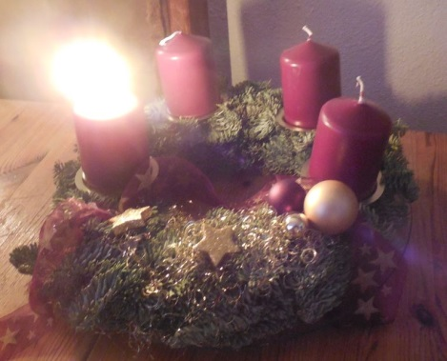 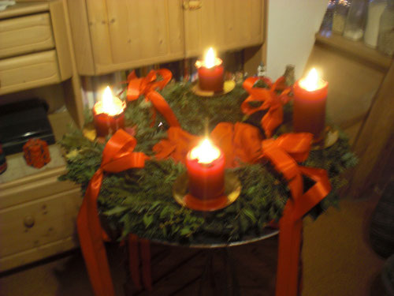 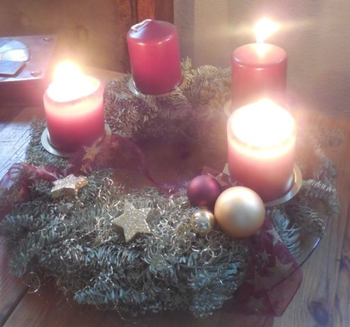 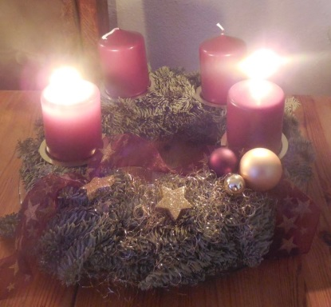

   

   

Name:______________________

4.8

**1**. **Advent Advent Advent _______________**