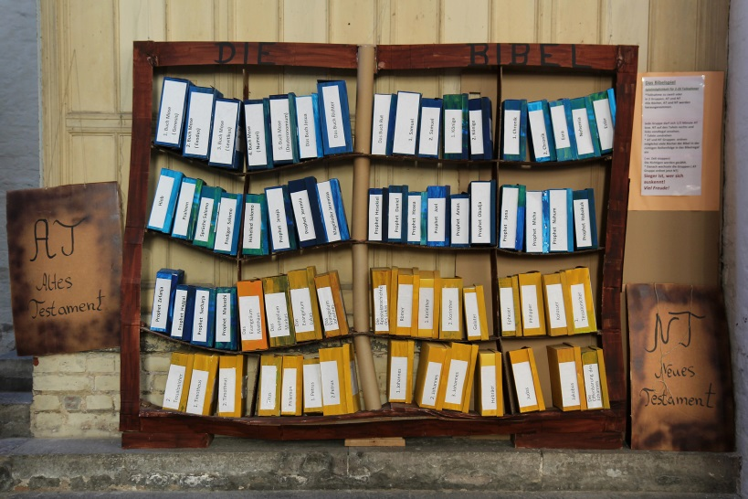
15. So entstand die Bibel

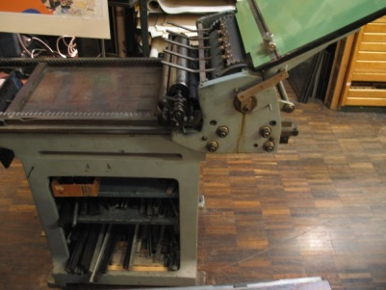
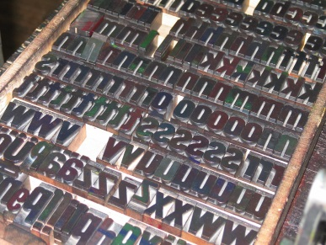
---------------------------------------------------------------------------------------------------------------------------------------------------------------------------------------------------------------------------------------------------- © Peter Weidemann, Pfarrbriefservice.de ---------------------------------------------------------------------------------------------------------------------------------------------------------------------------------------------------------------------------------------------------© Elfriede Klauer, Pfarrbriefservice.de

